Application Messaging Troubleshooting Guide

Problem: Cannot find message in Message Monitor

Possible causes:
- User does not have security for the message channel.
- The message monitor criteria have filtered out the message.

Problem: Messages are being processed in an incorrect order

Possible cause:
- The Channel has been partitioned, and the resulting subchannels do not match what was assumed for the ordering of the messages.

Problem: Message Instance not created

Possible cause:
- Message is inactive.

Problem: Message Instance stays in NEW status.

Possible cause:
- The pub/sub servers are not booted.
- The Message Dispatcher has crashed or has been brought down.
- The Item is not at the top of the queue. All messages with the same Channel/ Subchannel are in the same queue

Problem: Message Instance stays in STARTED status.

Possible cause:
- All Message Handlers have crashed or have been brought down. Processing will resume when Message handlers come brought back up
- The Message dispatcher processing the message is on another machine, and either the machine or the application server domain is down.

Problem: Message Instance stays in WORKING status.

Possible cause:
- Message Handler has crashed.
- The Message Handler processing the message is on another machine, and either the machine or the application server domain is down. The Message handler working on the message is “blocked”. The service will timeout, and the Message Dispatcher will retry the message.

Problem: Publication Contract not created

Possible cause:
- Channel routing rules not set up properly.

Problem: Publication Contract stays in NEW status

Possible cause:
- Publication Dispatcher has crashed or has been brought down.
- Message Channel paused.
- Node paused
- Previous message had a status of RETRY, ERROR, or TIMEOUT.
- The Publication Contract is not at the top of the queue. All Publication Contracts with the same Channel/ Subchannel and subscribing node are in the same queue

Problem: Publication Contract stays in RETRY status

Possible cause:
- The remote node cannot be “pinged” successfully. The publication contract will be processed when the remote node comes back up.
- No publication handler available, either because it’s crashed or it has been brought down.

Problem: Publication Contract stays in WORKING status

Possible cause:
- The publication handler processing the contract is on another machine and either the machine or the domain is down. Processing should continue when the pub/sub system on the other machine comes back up.

Problem: Publication Contract in TIMEOUT status

Possible cause:
- An exception occurred on the target application server (look at APPSRV.LOG file for details) verify the following:
- Source node defined in target database
- Verify correct password on node, target and source (if using passwords)
- Message or Channel not defined in target database
- Incorrectly routed reply. Check Gateway for correct machine address of target node
- No target local node defined
- Bad XML syntax

Problem: Subscription Contract not created.

Possible causes:
- Message Subscription is inactive.
- Channel routing rules not set up properly.

Problem: For a message published by the local node, subscription contract not created for local node even when Message Subscription is active and “Invoke for local publication” is checked.

Possible cause:
- The local node was not included in the routing rules for the channel. To subscribe to its own publications, the local node must be included in the channel routing rules.

Problem: Subscription Contract stays in NEW status.

Possible causes:
- The Subscription Dispatcher has crashed or has been brought down.
- Message Channel Node or System paused.
- Message Definition not Active.
- Previous message had a status of RETRY, ERROR, or TIMEOUT.
- The Subscription contract is not at the top of the queue. All Subscription Contracts with the same Channel/ Subchannel and subscription owner are in the same queue.

Problem: Subscription Contract stays in STARTED status.

Possible causes:
- The Subscription Handler has crashed or has been brought down.

Problem: Subscription Contract stays in WORKING status.

Possible causes:
- The Subscription Handler has crashed or has been brought down.

Problem: Subscription Contract in ERROR status.

Possible causes:
- Subscription PeopleCode errors
- Application data errors.

Problem: Subscription Contract in TIMEOUT status.

Possible causes:
- Subscription PeopleCode errors

Problem: Unable to ping a node.

Possible causes:
- The web server for the Gateway is down.
- The Gateway is not configured properly.
- The app server for the node is down.
- Verify url is correct. Copy url in browser address, should see “PeopleSoft <tools release> Application Messaging gateway”.

Problem: “Access denied, source node not found” message even when source node defined on target database.

Possible cause:
1. Known bug: Message Node caching not working. If a new node is added, reboot appserver.

Problem: “Bad Gateway, General Exception error ..” message when pinging node.

Possible cause:
- Check Opid/ Password of node on Configuration Servlet page. (http:// …/servlet/gateway.administration)

Problem: “Access denied. Target and source message node password's do not match.” message even when no passwords are defined on target and source nodes.

Possible cause:
- Target application server has entry in Distinguished Name field in source node’s message properties.
- Target URL must be defined with https:// on target node in source application server.

Problem: “Page cannot be displayed message when attempting to bring up Gateway or gateway Administration page.

Possible cause:
- Make sure Apache/ Jserv started.
- Make sure aliases are correct in zone.properties

Customer Problems and Resolutions:

Problem: Ping failed, Application server log message saying cannot find JVM.

Resolution: The application server was on a different machine as the web server. The Sun JRE 1.2 was downloaded on the web server machine. Sun JRE 1.2 was re-downloaded on the application server machine and the setting JavaVM Shared Library in psappsrv.cfg file was set to point to the location of this JRE.

Problem: All attempted publishing messages from PIA resulted in the following error message
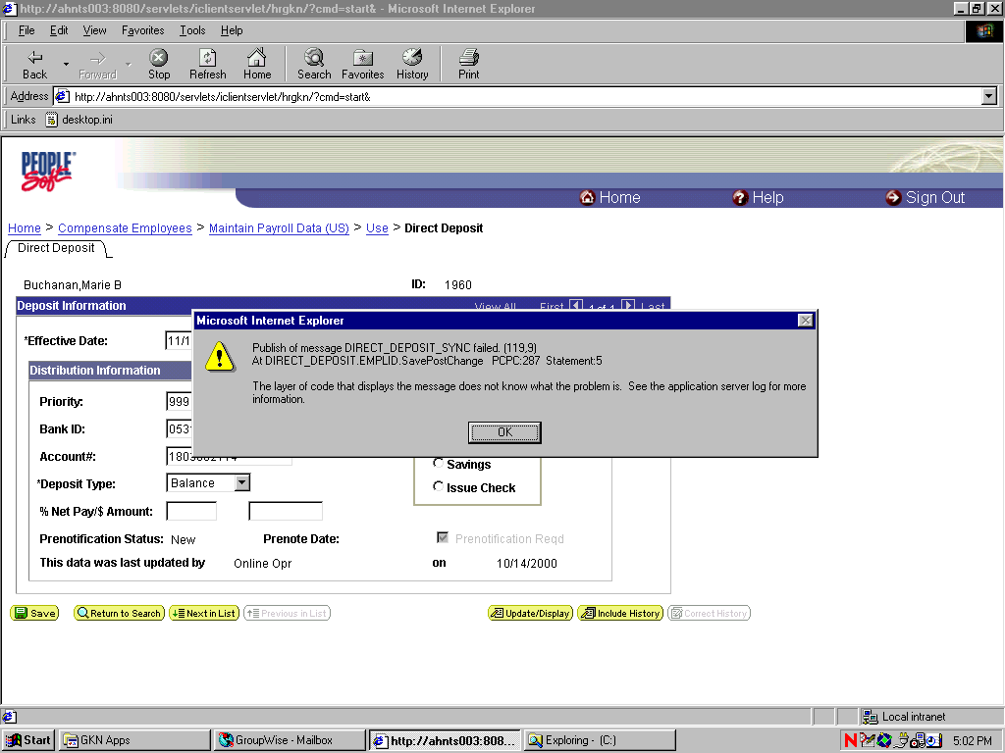

Resolution: When the upgrade was performed to the production database the following people tool tables had no data in them.

PSAPMSGPUBINST (channel names and latest pubid)
PSAPMSGPUBCSYNC (channel names and update timestamp)
PSAPMSGPUBSYNC (channel names and update timestamp)
PSAPMSGSUBCSYNC (channel names and update timestamp)

Problem: All publication Contracts remain in a NEW status.

Resolution: The queue was blocked from a Publication Contact that was in a status of ERROR from two weeks prior. User did not see the error on the message monitor because he was only looking at today. User entered xx day in and the ERROR publication appeared. Canceled the error and all subsequent publication contracts processed successfully.

Known Bugs:

- Message Caching does not work. What this means is if the local node is changed or another message node is added, then the application server will have to be cycled in order to pick up the change. This is also true if a Message Channel is added.

