Environment Management

User Guide
1.0 What is Peoplesoft Environment Management? 3
1.1 System Requirements 3
1.2 Definitions 3
2.0 Overview of Environment Management 5
2.1 Agent Functionality 5
2.2 Hub Functionality 6
2.3 Peer Functionality 7
2.4 Viewer Functionality 7
3.1 Installing the Agent 8
3.2 Installing the hub and Viewer 11
3.3 Installing Change Assistant 11
4.0 Running the components 12
4.1 Running the Agent 12
4.11 Starting an Agent 12
4.12 Stopping an Agent 12
4.2 Running the Hub 13
4.21 Starting the EM Hub 13
4.3 Running the Viewer 14
5.0 Configuration of EM 16
6.0 FAQ and Diagnostics 17
7.0 Troubleshooting 18
7.1 Unable to start an Agent 18
7.2 Agent does not recognize any of the installed components 18
7.3. Broken connection 18
8.0 Tuning 20
Appendix 21
Fig 1.1 Components the Environment Management 21
Fig 1.2 Schematic representation of a typical Environment 21

1.0 What is Peoplesoft Environment Management?

The Environment Management (EM) is a framework that gathers and publishes PeopleSoft install configuration and update information. EM also provides a vechicle to execute commands remotely on different machines on the netweok from a upgrade tool like Change Assistant. EM provides the ability to generate PeopleSoft Server machine diagnostic information. Change Assistant uses the EM to apply patches, updates and upgrades to PeopleSoft installations and configuration.

1.1 System Requirements

You must have installed JRE version 1.4 or later on NT and Unix for running the Agent. JRE 1.4.x is installed by the PeopleSoft installations.

1.2 Definitions

- Manageable Component: This refers to the components that can be individually managed from the EMF hub. An Mbean internally represents a manageable component. Examples of this are Mbeans for Application Server, Web Server, Process scheduler etc.

- Heart Beat: A Peer communicates with the hub in intervals. The intervals are referred to a ‘Heart Beat’. The default interval shall be configurable. On every heartbeat, the peer ‘pings’ the server to check if it has any pending messages. If it does, the messages are ‘taken’ and executed.

- Commands/Messages: The Peers communicate with each other by sending commands to other peers. The communication is always between the Peer and the hub and never directly between peers. Commands are ‘wrapped’ around in messages. The peers get a message and can extract the command from it. The peers then execute the commands and send responses.

- Environment: An environment in the EMF translates directly to all the management components in the enterprise that share the same GUID in the backend database. There can be more than one instances of a type of managed component in an environment. For example, development environments can constist of several application servers, process schedulers and web servers.

- EM Viewer: A command line tool to gererate a snapshot of the information published by the hub. Users have the ability to view this static data in HTML and navigate and obtain information about the different managed components in the system

- Crawling: The process of scanning the hard disk searching for patterns for manageable components. The hub has a set of configurable parametes by which the recrwal intervals can be altered. Based on this, the hub can issue a recrawl command to the agents to discover information on newly installed or changed configuration information

- Revalidate: The process of re-checking if the last set of managed components that have been discovered is still valid. The agent iterates through the list of components that have been discovered from the last recrawl. It then checks if the current set of configuration parameters for the managed components have changed the management scope for the component. If so, the information is updated. If the new set of configuration options has made the component not usable, it is removed from the list of managed components. This information is updated to the hub, the next time the agent restarts and communicates with the hub.

2.0 Overview of Environment Management

The Environment Management enables you to identify, and manage configuration data about PeopleSoft environments. This should help in implementing new environments and maintain existing environments. You can use the Environment Management Framework to obtain snap shot configuration and setup information about the web server, application server, individual hosts, Process Scheduler Server,.

Essentially, the Environment Management Framework will serve as a registry for all manageable elements and expose interfaces for manipulating them. EM consists of the following core components

- Agents
- Hub
- Peer
- Viewer

Fig 1.1 shows the interaction between components of the Environment Management. Fig 1.2 shows the schematic representation of a typical Environment. Sections 2.1 through 2.4 explain the functionality of the different components.

2.1 Agent Functionality

An Environment Management Agent is a Java executable. One one instance of the agent can run at a time. Initiates communication to the hub and is assigned a unique peer id. This is persisted and reused for later connections by the agent.

Users can see the peerid that is assigned to the agent, while it is running. In steady state, the following trace can be seen from an agent (from the heartbeat) that has been assigned a peer id of 3.

Sending pulse from 'com.peoplesoft.emf.peer:id=3'
Sending pulse from 'com.peoplesoft.emf.peer:id=3'
Sending pulse from 'com.peoplesoft.emf.peer:id=3'
Sending pulse from 'com.peoplesoft.emf.peer:id=3'

The agent consists of the following functions

Crawling

The agent scans the hard disk searching for patterns for manageable components. The metadata of the search results of the crawling, are saved to the local hard disk. On startup, if the agent detects missing metadata, it recrawls the hard disk for managable components. The directory path for crawling can be configured.

The following table shows the default directory paths for the agent

Operating System | Default Directory /Drives
Windows | C: and D:
Unix | $HOME/work

Publishing Management Information to the Hub

After detecting a managanble component, the agent reads the non-sensitve information from configuration files of the component. Some relevent information related to environment and patch levels is also fetched from the database that the applicaton server or process scheduler communicates to. The agent publishes this information to the hub

Heartbeat and command execution

On every heartbeat, the agent ‘pings’ the server to check if it has any pending messages. If pending messages exist for the agent, they are retrieved from the hub and executed locally.

Configuration Parameter | Default Interval
pinginterval | 10000 (in milliseconds for the heartbeat)

2.2 Hub Functionality

The Environment Management hub is a Web application that is installed with PIA and portal. It is started along with the rest of the web applications when the user boots the web server. The hub is the broker for all communication between peers.

The hub constists of the following functionality

Registration: The hub registers all the information that is publshed by the agents. It also assigns a unique peerid for every peer that engages in a dialogue with the hub.

Configuration Information Registration: Handles updates to configuration information, co-relation of information and grouping into environments based on the information publsiehd by the agents.

Peer Health: The hub maintains Useful information on the ‘health’ of a peer. Users can access the health information directly from a URL. Refer to Fig 1.3 for accessing hub through URL.

Message Broker: Services message service requests and responses from peers. The messages can be delivered to the respective peers even if the peers are not currently running. They are picked up the next time the peers ‘call in’ to the hub

Self-Configuring Recrawl and Revalidate commands: The hub issues automatic recrawl and revalidate commands to the agents. The following table shows the default time intervals for the recrawl and revalidate

Configuration Parameter | Default Interval
recrawlinterval | 24
revalidateinterval | 6

2.3 Peer Functionality

Peers are independent Java applications that communicate with the hub to query information that has been registered at the hub. They can also request the hub to deliver messages to specific peers

Peers consist of the following functionality

Query Information Communicate with the Hub to query the published information. Can get the list of peers connected, mbeans and the information published by them

Direct Messages to peers Peers can target messages (that contain commands) to a particular peer based on peerid and get responses

2.4 Viewer Functionality

This is a command line tool developed to assist customers with the viewing of data retrieved from the PeopleSoft Environment Management Hub. Data retrieved from the hub is saved to an XML file. The XML file contains data that are specific to individual customers, such as Environment information, Software Updates information, Host information, File Server information, Application Server information, Process Scheduler information, and Web Server information.
3.0 Installation Steps

3.1 Installing the Agent

Agents are installed as part of the standard CD installs of People Tools software, The EM Agent will be installed under a PSEMAgent directory under <ps-home> directory. The EM Agent shall be installed if atleast one set PeopleTools software is installed on a machine. If additional components are installed under the same <ps-home> location, the installer shall warn the user of overwriting existing software.

If the user chooses to create multiple ps-home directories, they may end up having multiple copies of the EM agent binary. However, in the current release of the EM, only one instance of the EM agent can run from a machine at a time.

The following panels have been added to the standard CD install specific to EM related information

Environment Hub Configuration panel

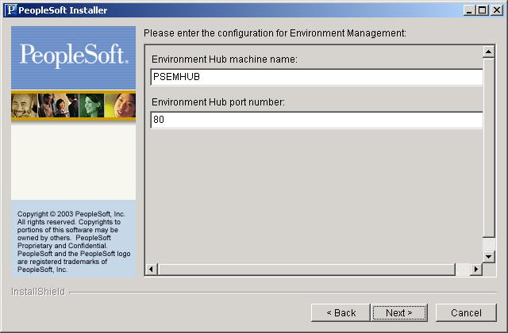

Select the machine name of the web server running the EM Hub(For developers, this will likely be the machine they will be running PIA on). Select the hub port number(default is 80). This needs to match the PIA port. If you change the port number for the agent configuration, you must also change the PIA web server listener port number- See Hub Configuration section.

CD install then checks if an EM agent is previously installed and running on the machine.

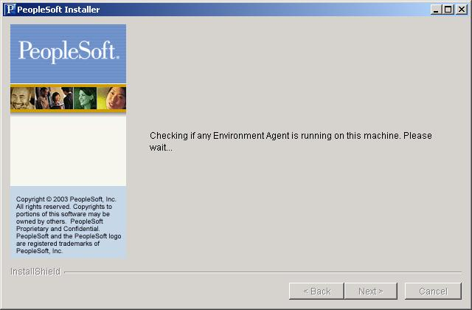

If there are no EM Agents currently running, the installer will start the EM agent
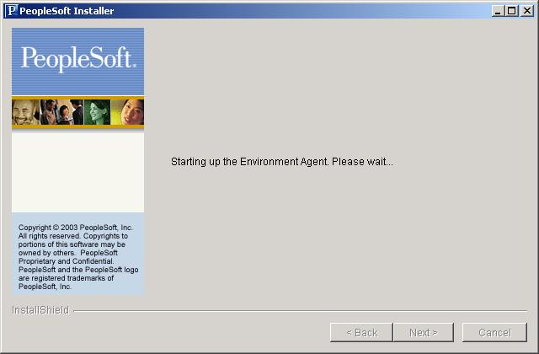

If the agent cannot be started due to another EM agent running on the machine the user will see this dialog, instead of the one above. 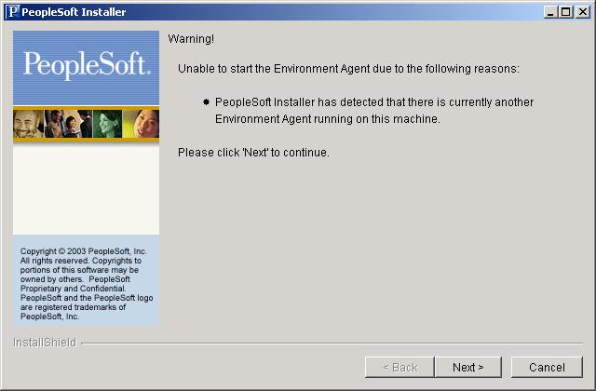

If the user decides not to run the agent, they can disable or stop the agent post-installation. See the Configuring and Managing the EM Agent section.

Common error cases for the Agent

(All error cases where the agent is not able to communicate with the hub, the following error message shall be displayed to the logs and stdout)

Broken connection - attempting to reconnect
RemoteException while connecting to server - retrying attempt 1
RemoteException while connecting to server - retrying attempt 2
RemoteException while connecting to server - retrying attempt 3

The agent attempts to reconnect to the hub with the parameters that are specified in configuration.properties.

Agent is started but the hub is not started:The agent will be able to reconnect once the hub is started with StartPIA script

Agent is started but the web server is configured to run on a different machine: Edit the configuration.properties andd change the huburl parameter (see section - Configuring and Managing EMF Agent).

Agent is started but the web server is configured to listen on a different port: Users will continue to see the same error message displayed above. Edit the configuration.properties file (see section - Configuring and Managing EMF Agent) and change the port number for the huburl. Shutdown and restart the Agent.

The Agent is running and communicating with the hub, and PIA is shutdown: Users will see the broken connection error message. Once PIA is started, the connection shall be restored.

3.2 Installing the hub and Viewer

The EM hub is installed as part of the standard PIA installs. EM Hub supports both single server and multi- server installs. The EM hub run on WebSphere or WebLogic servers.

The EM hub is deployed in the J2EE containers as WebApplication modules. They can be managed like any of the standard Web application modules in Web Logic and Web Sphere.

The following directories related to EM Hub are created on the J2EE container for the EM Hub

<ps-home>\webserv\peoplesoft\<domain>\PSEMHUB.

The required jar files for the Environment Management hub are installed under the WEB-INF\lib subdirectory.

Installing the Viewer:

The Viewer is only installed on PeopleSoft Web servers, under ps_home\PSEMViewer. There are no additional installation steps required by the user.

3.3 Installing Change Assistant

Link to CA userguide installation section

4.0 Running the components

4.1 Running the Agent

4.11 Starting an Agent
There are two startup scripts for starting an agent depending on the platform.

Windows platform
<ps-home>\PSEMAgent\StartAgent.bat
Unix platforms
<ps-home>\PSEMAgent\StartAgent.sh

If users wish to make components manageable at start up, they may wish to include the start up applications on Windows and login scripts on Unix. If an Agent is already started, the user may get error messages, check the section on 'Troubleshooting' for more information on this. Only one agent can be started per machine.

4.12 Stopping an Agent

Windows platform
<ps-home>\PSEMAgent\StopAgent.bat
Unix platforms
<ps-home>\PSEMAgent\StopAgent.sh

4.13 Command line arguments for the Agent

The following table shows the command line arguments that can be used with the agent. Run the command line options with the startAgent.bat (or startAgent.sh) scipt

StartAgent <command_option>

Option | Description | Sample output
version | Returns the version of the Agent | Version:8.44 Build Number: 109
shutdown | Shuts down a previous instance of the agent if it is running | If agent does not exist  Shutting down Agent....  Unable to detect a running agent...  Instance does not exist  It agent exists,  Shutting down Agent....  Shutdown normally
url | Prints the URL of the hub that the agent is configured to communicate with | http:// 216.131.222.227:80/PSEMHUB/hub
Validate | Validates the current set of managed components that have been discovered from the last crawling by the agent | NA
Recrawl | Recrawls the hard disk to detect new configurations. The current search-results.xml file is backed up | NA

4.2 Running the Hub

4.21 Starting the EM Hub

Single server install:

For a single server installation, the EM Agent is part of the PIA server. To start the PIA Server and the EM hub, run the follwing batch file

<install - dir>\webserv\peoplesoft\startPIA.cmd

and PSEMHUB is loaded. PIA server listens on port 80 by default. This is important for configuring the agents to communicate with the EM hub

Multiple server install

EM supports multi server installs, HOWEVER, CLUSTERING IS NOT SUPPORTED BY EM HUB. The EM hub persists meta data into the file system on the J2EE container. This is not replicated in a clustered environment. Users will end up getting erroneous behavior by attempting to run the EM hub in a clustered environment.

EM Hub will deal with large binary files that are sent across from the Change Assistant to the Agents by using the Hub as the intermediary dispatcher. This can create significant overhead to a production system running on a multi server clustered environment. So the following steps are recommended for a multi server installation (clustered or non clustered environment)

Configure the EM Hub to run on a server that is different from the PIA servers.
Disable PIA on the server that runs the EM. Configure the reverse proxy to redirect any network traffic with a URI of EMHUB to the server running the EM hub

Executing the following commands in sequence can start EM Hub in a multi server install

<install -dir>\webserv\peoplesoft\startWeblogicAdmin.cmd (Start the admin server )
<install -dir>\webserv\peoplesoft\startManagedWeblogic PSEMHUB

Stopping the EM Hub

Single Server

Executing the batch file can stop the Single Server

<install - dir>\webserv\peoplesoft\stopPIA.cmd

Stopping a hub while the will cause the agents that are still running on remote machines to loop for ever trying to make a connection and continue operations when it is successful

Multi Server Install

<install -dir>\webserv\peoplesoft\stoptWeblogicAdmin.cmd (Stops the Admin Server - If admin server is not stopped before the PSEMHUB server is stopped, the server will be restarted by the admin server)

<install -dir>\webserv\peoplesoft\stopPSEMHUB.cmd

TBD: Get the corresponding command for WebSphere from Sunil

4.3 Running the Viewer

Viewing data from the Environment Management Hub is a two step process. Users need to run a java program to connect to the hub and retrieve the information in XML format. Then, users open a delivered html file to view the information in the generated xml file.

To run the java program, from ps_home\PSEMViewer run: GetEnvInfo.bat (on Windows) or ./GetEnvInfo.sh (on UNIX). Due to security concerns, we've implemented the java program to only connect to "localhost". Sample output is shown below

**********************************************************
* PeopleSoft Environment Management Viewer *
**********************************************************

Enter the Web Server port:
6071 <== Enter the server port. Make sure the hub is reachable.

Sending pulse from 'com.peoplesoft.emf.peer:id=2'<== Here Peerid is 2. It varies from machine to machine

C:\pt844\PSEMViewer\envmetadata\data\viewer.xml exists. Renaming it to <== if the file exists, it'll
C:\pt844\PSEMViewer\envmetadata\data\viewer.xml_2003_9_22_11_20_50308.xml be renamed to a temp file.
PeopleSoft Environment Management Viewer has written contents from the
EMF Hub to C:\pt844\PSEMViewer\envmetadata\data\viewer.xml <== output file is written to viewer.xml
under ps_home\PSEMViewer\envmetadata\data

**********************************************************
* PeopleSoft Environment Management Viewer Terminated Successfully.
**********************************************************

To view information retrieved from the hub, users open the delivered HTML file (ps_home\PSEMViewer\envmetadata\data\viewer.html) with a PeopleSoft supported browser:

5.0 Configuration of EM

The following parameters need to be configured in the EM agent to initiate communication with the EM hub.

- huburl - This is the url that contains the host name and the port number of the machine on which the EM hub is running (inside a J2EE container)

- agentport - This is a port that the agent uses for internal life cycle management

- windowsdrivestocrawl (on Windows OS, Ignored on Unix platforms). This is the set of local drives (not network mounted drives) that the contains one or more installed peoplesoft components.

- unixdrivestocrawl - Same semantics as the windowsdrivestocrawl parameter. Howvere, this is for Unix systems

- pinginterval - This is the interval in seconds between two successive heartbeats the peer sends to the hub. All peers that access this configuration file will have the same ping interval

- recrawlinterval - This is the interval in hours between two successive re crawl commands issued to a peer. The server only issues re crawl commands to agents that are connected to the hub and have no pending messages in the queue. This configuration parameter is ignored by the agent

Fig 1.4 shows a typical configuration file for an agent

6.0 FAQ and Diagnostics

How do I check for the list of components that have been discovered in my system where the agent is running?

The results of searching the hard disk are saved in the envmetadata\data\search-results.xml file. Open this in an XML editor of your preference or in Internet Explorer on a Windows operating system. A sample search-results.xml file is attached

2. What versions of application servers, process schedulers are supported in EM?

For the 8.44 release, only versions 8.44 of app server, process scheduler and file server are supported.

3. I have installed new software components. Why does my agent not pick up the new components?

To improve on performance, the agent does not crawl every time it starts up. The agents crawl only if the search-results.xml file does not exist. Users need to explicitly issue a command to the agent to recrawl. The following sequence of steps is to be performed to make the new components manageable.

a). Stop the agent if it is currently running
b). Issue a StartAgentWL.bat recrawl command. This will force the agent to re crawl and create a new search-results.xml file. The old file is backed up.

4. I have changed a few configuration parameters to my application server (or process scheduler). How do I force the agent to pick up the new changes?

The user needs to re validate the components. Re validation will not detect newly installed components. The following sequence of steps is required

- Stop the agent if it is currently running
- Issue a StartAgentWL.bat validate command. This will force the agent to re crawl and create a new search-results.xml file. The old file is backed up.

7.0 Troubleshooting

7.1 Unable to start an Agent

Symptom

Get an error

Error initializing agent. Verify if another agent is not running on this machine or if you have the required permission to run the agent

Possible resolutions

Check if an agent is already running. If the console for the agent is not visible, check in the Windows task manager for the list of Java processes that are currently running.

Try to stop a running agent by invoking the scripts to stop the agents and then try to re start the agent

Check if the agentport is available. If not choose a different port to start the agent

7.2 Agent does not recognize any of the installed components

Symptom

The search-results.xml file does not exist or contains only an entry for Host

Possible resolutions

The agent needs to have permission to read directories as well as execute programs. Grant these permission for the Agent
Check if the disk is full.The agent perhaps has no disk space to create search-results.xml file
Check if the Agent has permission to create a file on the local file system

7.3. Broken connection

Symptom

Agent gives the following error messages

Broken connection - attempting to reconnect
RemoteException while connecting to server - retrying attempt 1
RemoteException while connecting to server - retrying attempt 2
RemoteException while connecting to server - retrying attempt 3

Possible resolutions

The hub is not running. Bring the PIA server backup. There is no need to stop and re start the agents

8.0 Tuning

Is this necessary?

Appendix

Fig 1.1 Components the Environment Management
Peer
Peer
Hub
Agents
Agents
Agents

Http Http

Fig 1.2 Schematic representation of a typical Environment
s
EM Hub
(Servlet)
Machine A

Manageable
Components
Inbound queue
Outbound q

Agent
Machine A

Manageable
Components
Inbound queue
Outbound q

Agent
J2EE container

Outbound queue maintained per peer

Change Assistant machine
(Another peer)

Inbound queue

Outbound q

EM Viewer
(Another peer)

The viewer will be able to run on the machine where the hub is installed. Generates snapshot in XML

Fig 1.4 Typical Configuration.properties

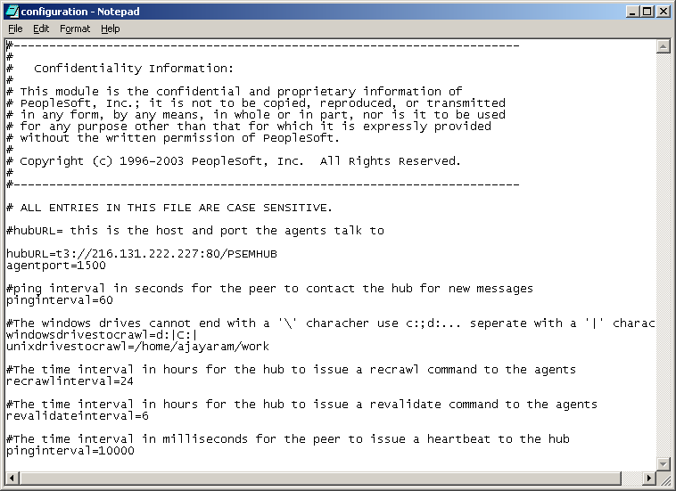

Fig 1.5 Typical results of a crawling by an agent
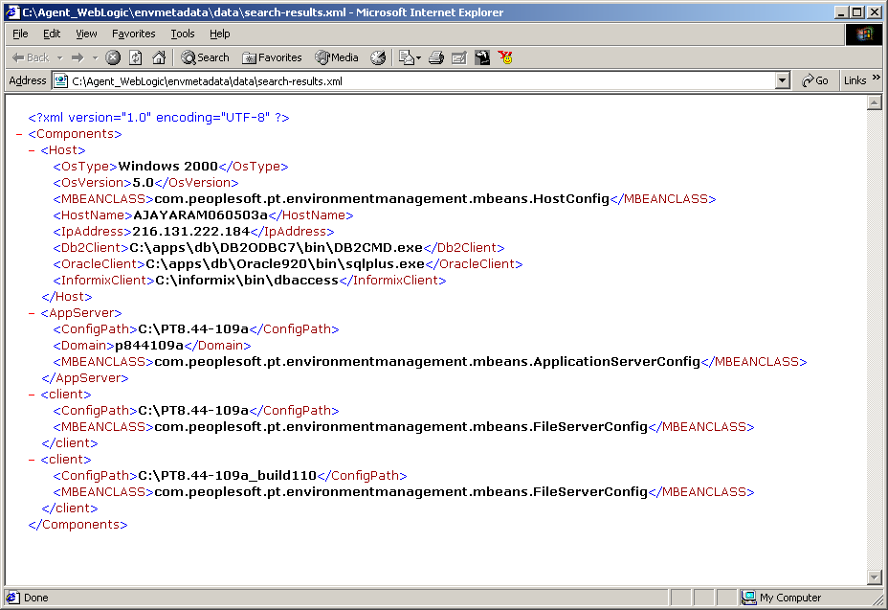

Reverse Proxy role in the traditional PIA server (without EMF)

Reverse Proxy
(Load Balancer)

Redirects the HTTP request to any one of the PIA Servers. There is no state information that is dependent on the server instance that the request is routed to
PIA Server1
PIA Server2
PIA Server N

Reverse Proxy role in the PIA server in the 8.44 release (with EMF)

PIA request
Reverse Proxy
(Load Balancer)

Redirects the PIA HTTP requests to any one of the PIA Servers.

EMF HTTP requests shoiuld be routed to the SAME EMF server
PIA Server1
PIA Server2
PIA Server N
EMF Server

Incoming EMF request

